CMPS 312 Mobile App Development

**YalaPay**

**Dr. Abdelkarim Erradi**

**Project Phase #1**

|  |  |  |
| --- | --- | --- |
| **Name** | **QUID** | **Contribution** |
| Mohammed Alromaihi | 202002029 | **25%** |
| Ibrahim Aboulibdah | 202001803 | **25%** |
| Deya Aldeen Abdelbaset | 201707314 | **25%** |
| Ahmed Adam | 202204608 | **25%** |

**Project Contribution Description:**

We split the screens between us, but everyone helped each other in the meetings or by asking questions on WhatsApp, the providers and models were done individually based on whoever needs them, then we grouped together on the last day to work on navigation and making the last changes to the code.

**1-Mohammed Alromaihi:**

Worked on the Invoice List screen and Invoice Details screen.

1. **Ibrahim Aboulibdah:**

Worked on the Login Screen, Dashboard Screen and the Customer Screen.

1. **Deya Aldeen Abdelbaset:**

Worked on the Deposited Cheques Screen.

**4-Ahmed Adam:**

Worked on the Invoice Report Screen and the Cheque Report Screen.

**Screenshots**

**-Login Screen:**

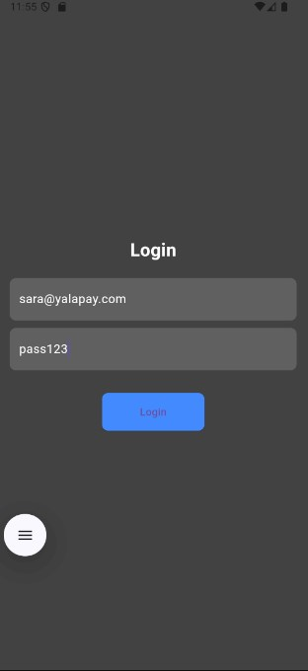

**-Dashboard:**

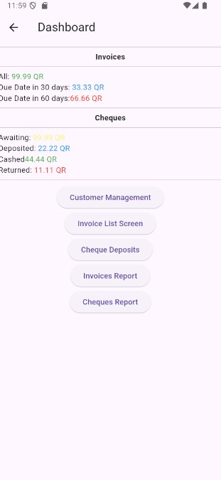

**-Customer Management Screen:**

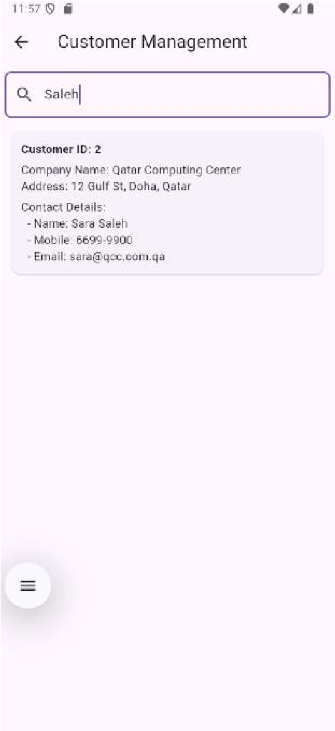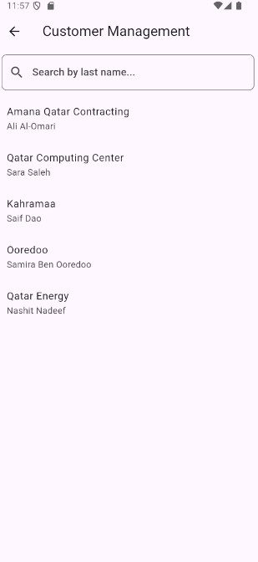

**-Invoice List screen:**

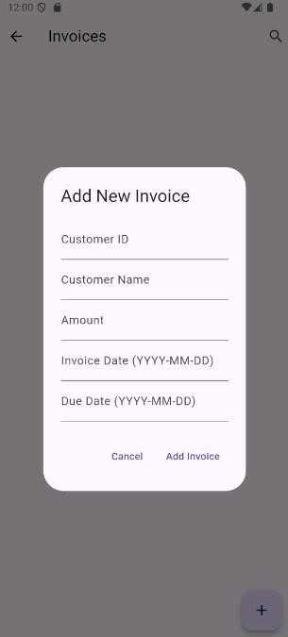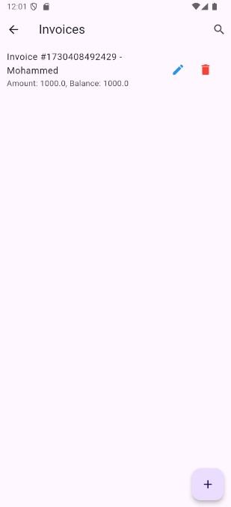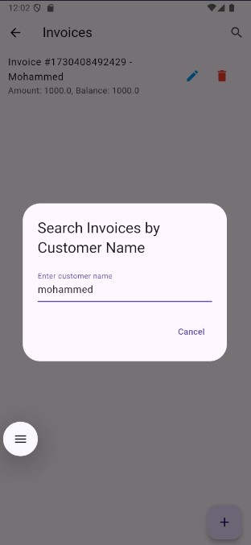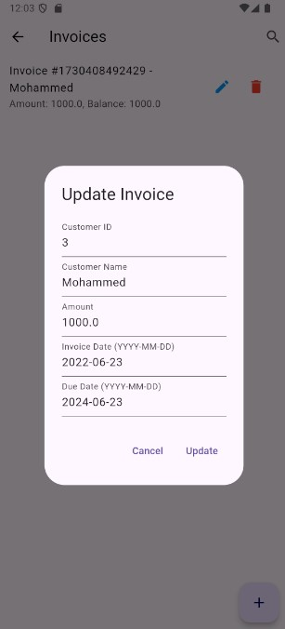

**-Invoice Details Screen:**

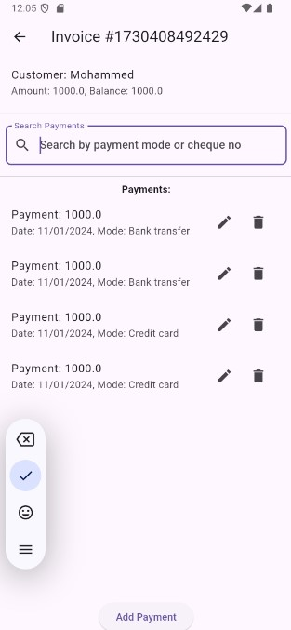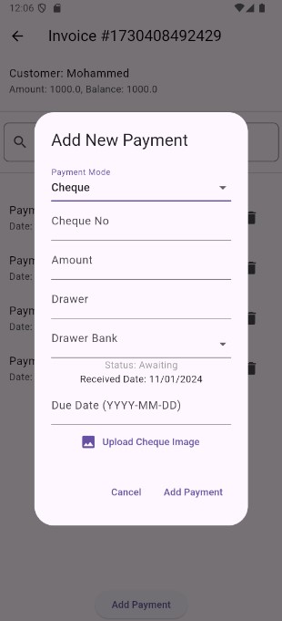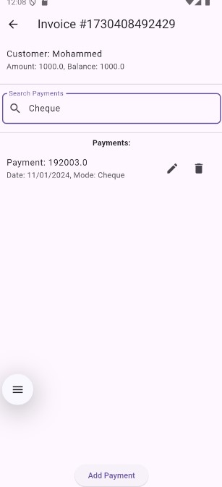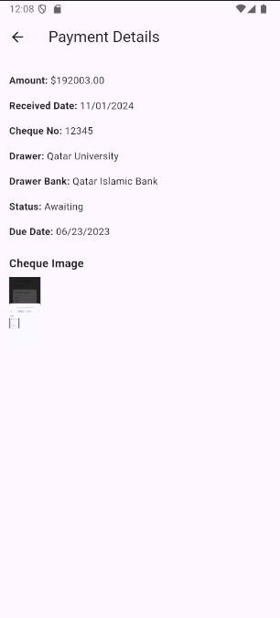

**-Cheque Deposit Screen:**

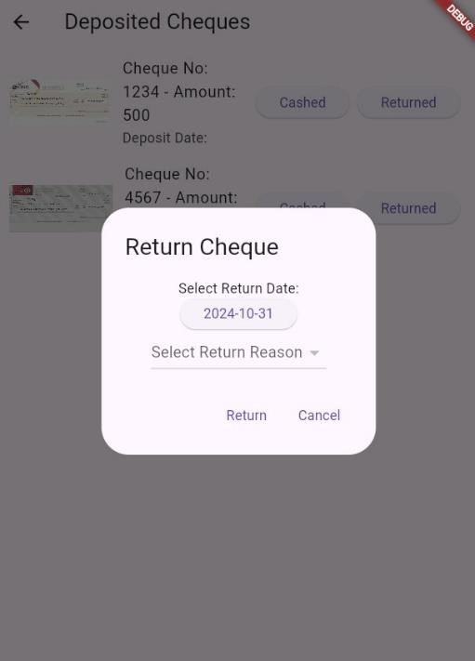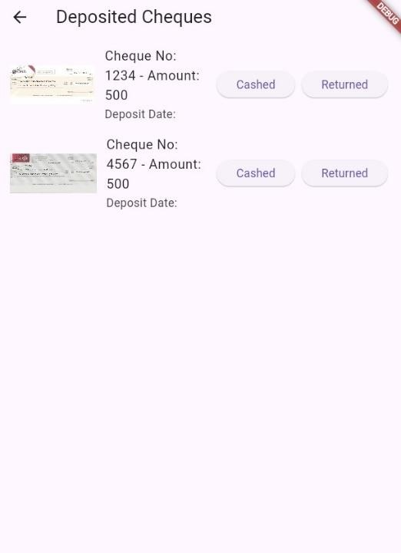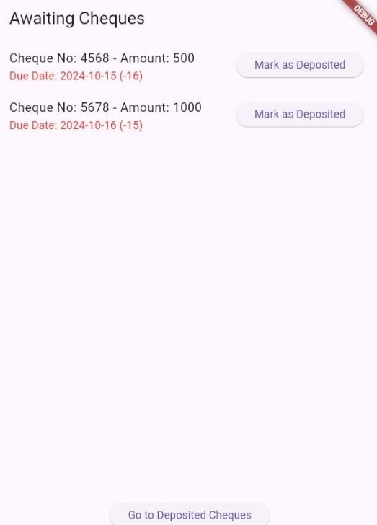

**-Invoice Report Screen:**

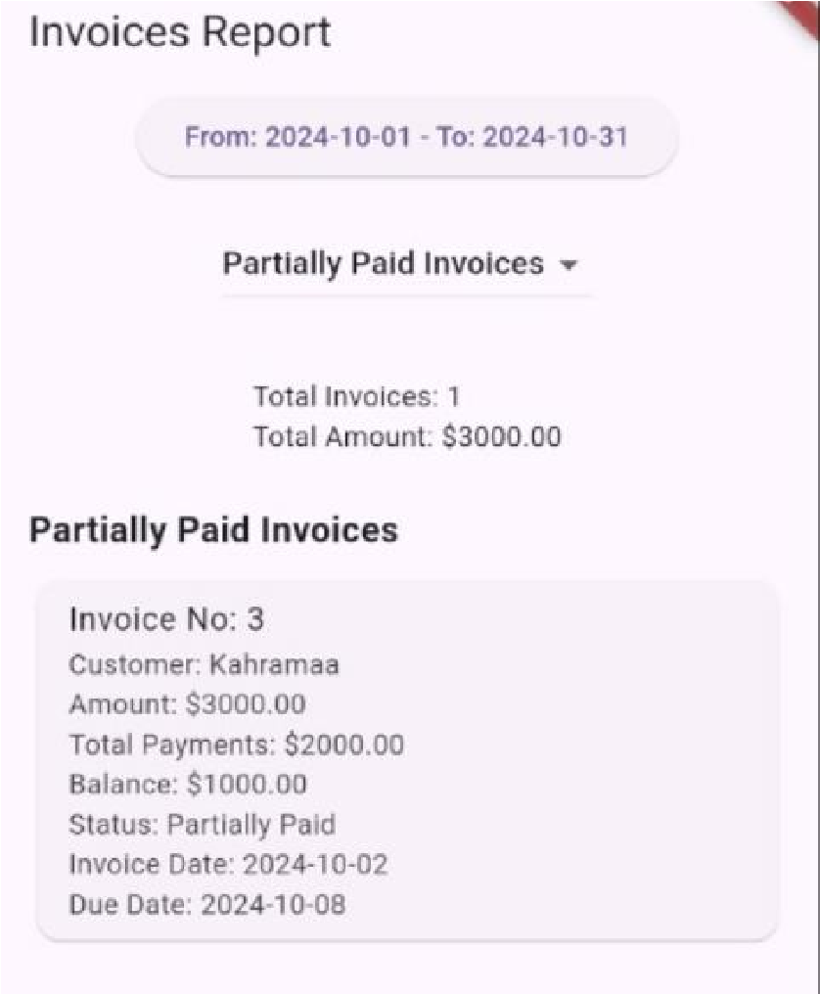

**-Cheque Report Screen:**

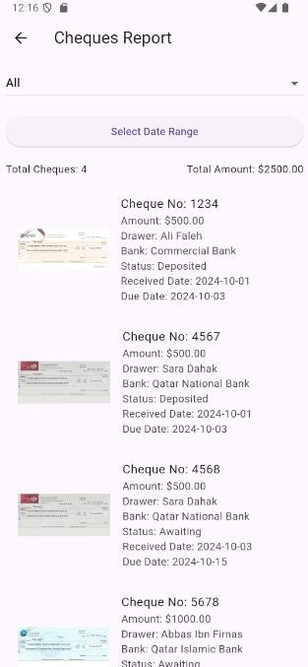

**Figma Design**

**We didn’t stick to the Figma template since at first we didn’t know much about app design, but as we kept working on the project we made huge changes to the design we brainstormed at the beginning.**

**This is our first concept design:**

